**Google Play Store Dataset Analytics**

***Wireframe documentation***

**Author:- Mangesh Yadav**

Homepage

As per problem statement, we have divided analysis into nine sections: - 1. Relation between category and reviews.

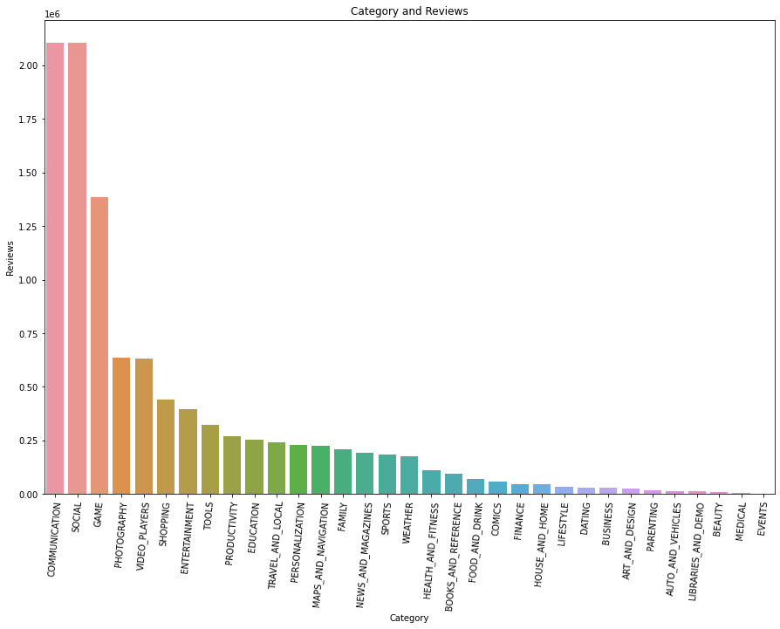

1. Relation between category and installs.

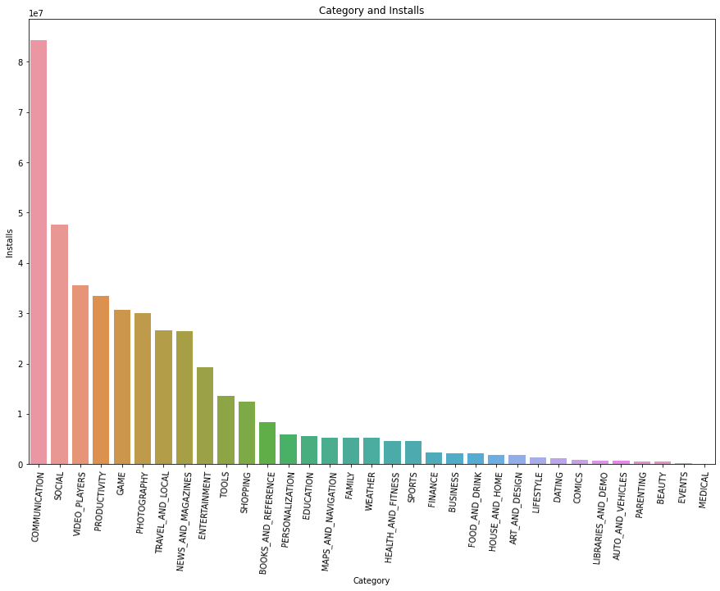

1. Relation between content rating and count.

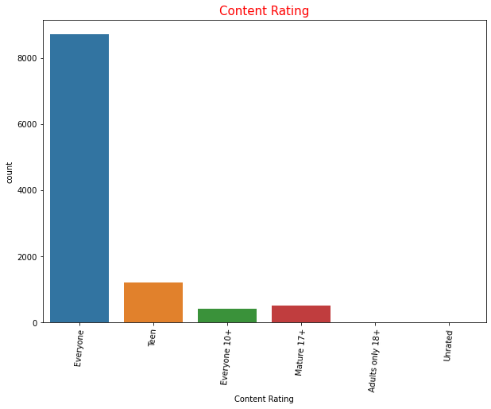

1. Relation between genre and count.

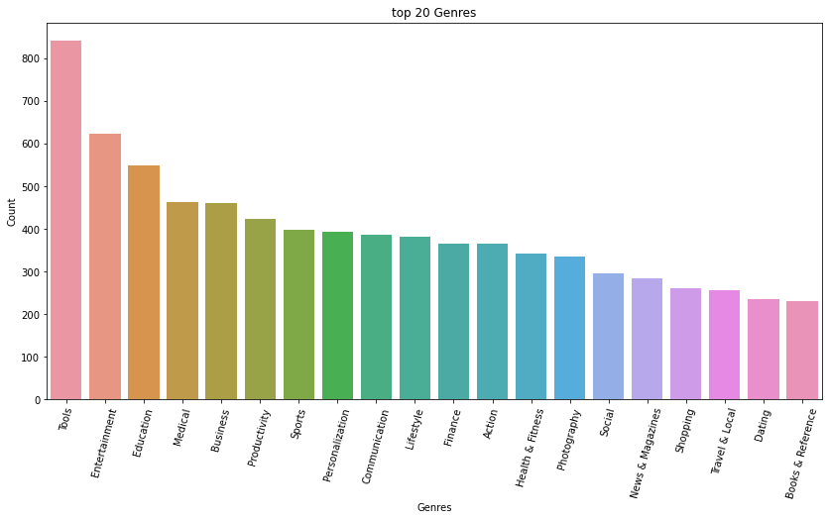

1. Relation between genre and installs.

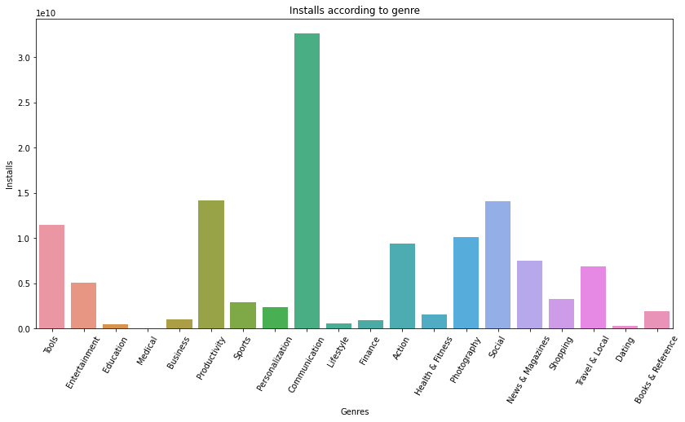

1. Distribution of rating.

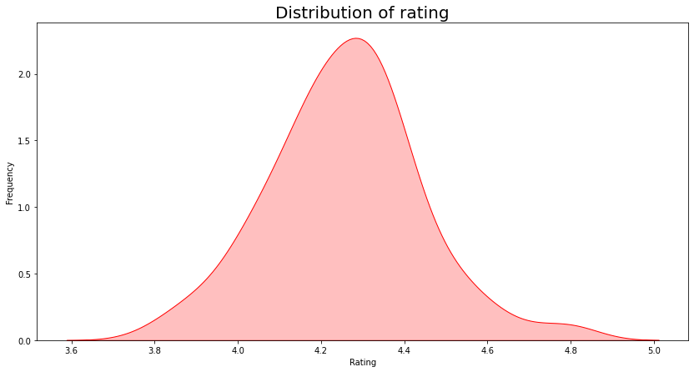

1. Relation between category and count.

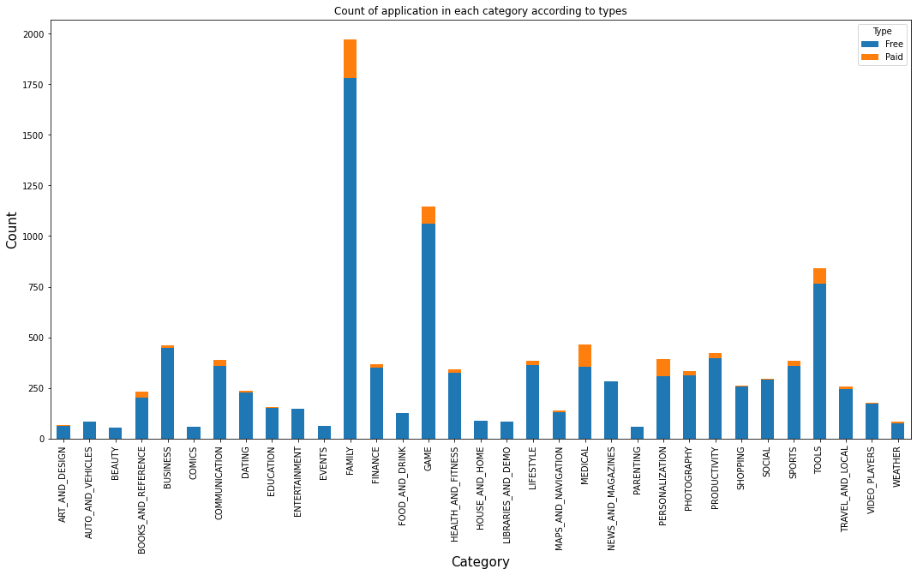

1. Distribution of size.

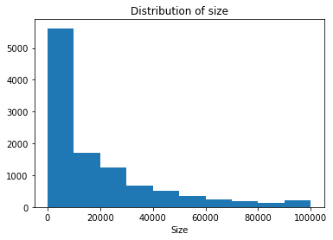

1. Category and sentiment count.

